**DNA**

DNA:

* Short for deoxyribonucleic acid / deoxyribose nucleic acid.
* Found in the cells of all organisms.
* Contains information to determine cell structure and how it functions.
* 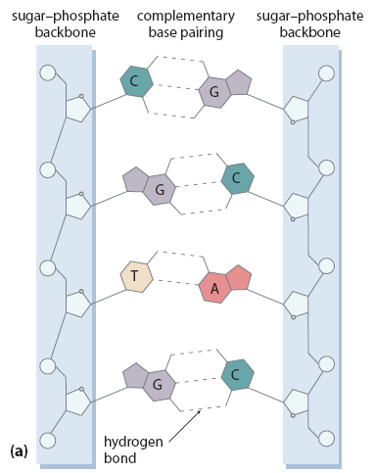2-3m long but only mm thick.

Phosphate

Deoxyribose Sugar

Nitrogen bases

Nucleotide

* Sections of the DNA molecules **make up the genes** which contain the **genetic code** which is the stored information that **determines the structure and activities of the cell**.

There are 4 nitrogenous bases and they pair together in a certain way.

* **Adenine (A)** is always paired with **thymine (T)**.
* **Cytosine (C)** is always paired with **guanine (G)**.
* One gene can be comprised of 1000 pairs of these bases.
* The nitrogen bases have **complementary shapes**.

Replication:

* The process of **doubling the genetic information during interphase** (when no cell division is occurring).
* Replication **begins at the origin of replication** where a “**replication fork**” has been created.

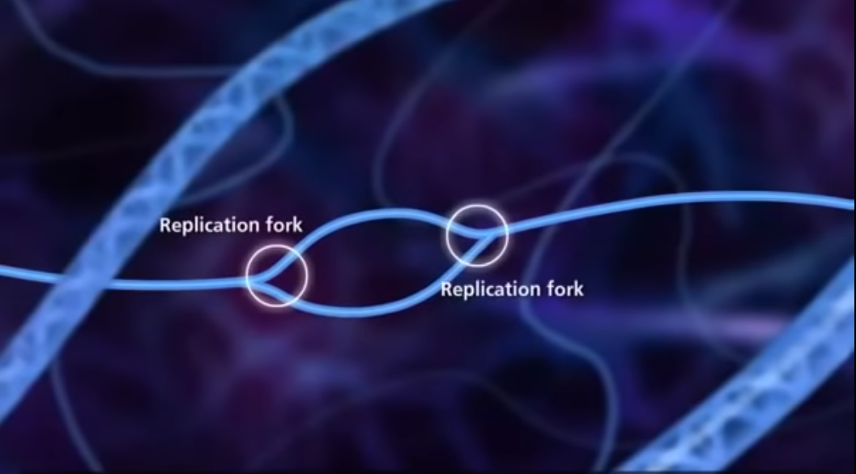

* **Helicase** enzyme **splits the hydrogen bonds between the complementary base pairs** of the **parent strands**.
* **Single-stranded binding (SSB) proteins stabilize the strands** to **stop DNA from binding together**.
* **Gyrase stops the DNA outside of the replication fork from coiling** (keeping it stable).
* **DNA polymerase** enzymes **bring free-flowing complementary nucleotides** to the **template strands**.
* **Primase** enzyme **brings primers** (short strands of RNA) to the **template strands**. Note: **DNA polymerase needs a primer to build off**.
* **Continuous synthesis** occurs on the **leading strand**.
* **Discontinuous synthesis** occurs on the **lagging strand**.
* **Okazaki fragments** (short fragments of synthesized replicated strand) are on the **lagging strand**.
* DNA **ligase joins the Okazaki fragments** together.

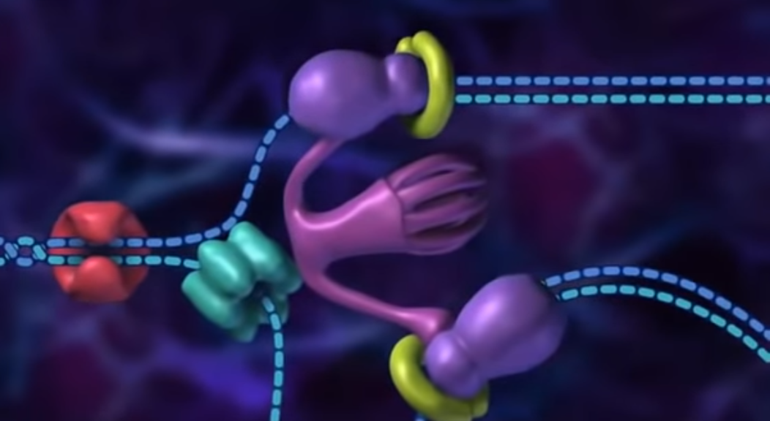

Lagging strand

Parent strand

Leading strand

Parent strand

DNA polymerase

Helicase

DNA gyrase

Clamp loader

**Protein Synthesis**

**Protein synthesis**: The process of **forming proteins** by using DNA code.

There are 2 parts to protein synthesis:

1. **Transcription** – Copying DNA into a **single RNA strand** in the nucleus. Note: DNA is double-stranded and too large to fit through the nuclear pores so a single strand of RNA is necessary.
2. **Translation** – The process of **forming bonds between amino acids** to form the protein. This occurs on the **ribosomes**.

Transcription:

* The process by which the **mRNA is formed** using the code in a DNA molecule.
* **Genetic instructions** are copied (transcribed) from the DNA **to the mRNA molecule**.
* **Chemical messengers** cause **RNA polymerase** enzyme to **begin mRNA production**.
* Other enzymes, called **helicases**, make the **double-stranded DNA molecule come apart**.
* RNA molecules have the base **uracil (U) instead of thymine**.

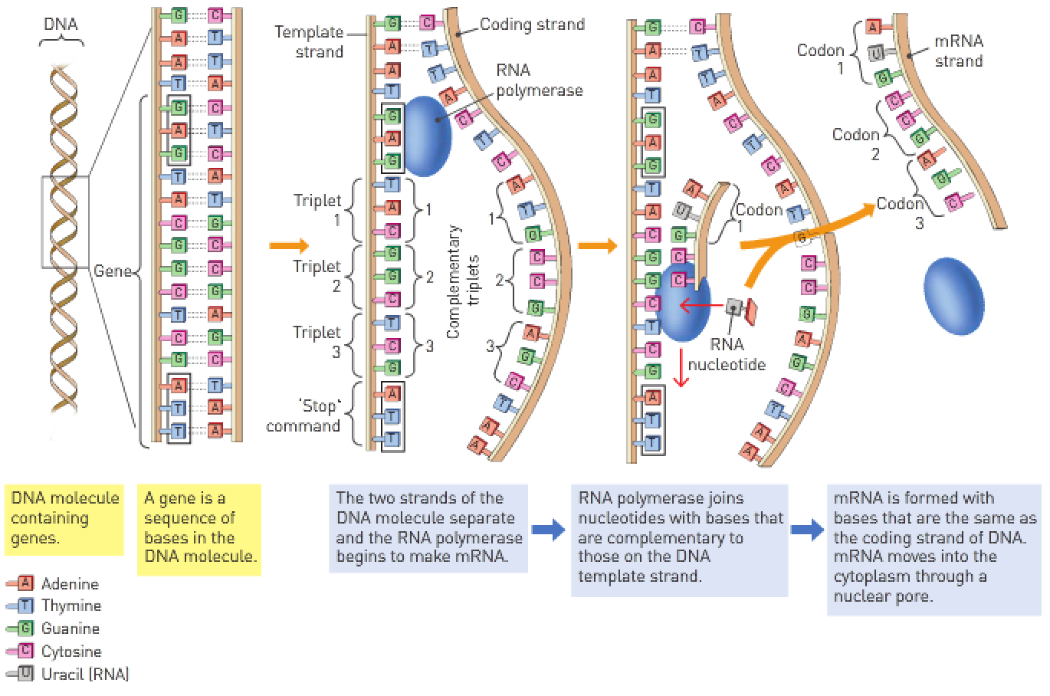

* Only **one of the strands of the DNA molecule is copied** during transcription.
* The strand that’s **copied** is called the **template strand** and the **other** strand is called the **coding strand**.
* A hormone (chemical messenger) arrives at the cell and either **binds to a receptor protein** (**amine** hormone) or **moves straight into the cell** (**steroid** hormone) and **activates genes in the nucleus**. Note: The **amount** and **type** of protein to be synthesized is **in the message of the hormone**.

Transcription:

1. DNA **helicase** enzyme **splits the hydrogen bonds between the nitrogen base pairs** at the spot on the DNA that needs to be transcribed.
2. The spot at which transcription starts contains a gene called a **promotor gene**. **RNA polymerase** enzyme starts to **match complementary bases at the promotor gene**. Note: The **template strand** of DNA that’s **transcribed** is called the **antisense strand**. The **coding** strand that **isn’t transcribed** is called the **sense strand**.
3. **RNA polymerase matches bases** that are floating in the nucleoplasm and **builds a strand until a “stop” gene signals the RNA polymerase to stop building**. Note: A unit of 3 nucleotides is called a **triplet**. **Uracil replaces thymine** on the RNA strand.
4. The finished product of transcription is called **messenger RNA (mRNA)**.
5. On the mRNA, there are **codons** (3 nucleotides that code for an amino acid) and there are **non-coding parts**. The **codons (coding parts) are called exons**. The **non-coding parts are called introns**. **Introns are removed from the mRNA** before it moves through the nuclear pores to the ribosome.

Translation:

* In the cytosol, a **ribosome attaches to one end of the mRNA molecule**.
* There’s a particular **sequence of bases** that are a **binding site for the ribosome**. This ensures that the **ribosome attaches to the correct end** of the mRNA.
* **Codon**: A group of **3 nucleotides** that’s the **code for an amino acid**.
* The codon **AUG** is called the **start codon**; when the ribosome reaches this codon, it **starts making protein**.
* Small molecules of RNA called **transfer RNA (tRNA) bring the individual amino acids to the ribosome** to be **joined together as proteins**.
* Halfway along its length, the **chain of nucleotides in the tRNA forms a tight loop consisting of 3 bases** that form an **anticodon**.
* The 3 bases of the **anticodon can bind with the complementary bases of a codon on the mRNA molecule**.
* The **anticodon determines the type of amino acid carried by the tRNA**.
* The **amino acid carried by the tRNA are joined together** so that the **protein is assembled with the amino acids in the correct sequence**.
* For **each bond formed** between amino acids, the **breakdown of ATP is required**.

Translation:

1. mRNA on the ribosome contains codons. The **start codon for translation is AUG (methionine)**.
2. A molecule called **tRNA brings anticodons** (3 nucleotides that match the codons) **to the mRNA strand**. Note: Transfer RNA is a “looped” molecule with anticodons located at the bottom.
3. The transfer RNA (tRNA) moves off and a **new tRNA brings the next anticodon to match the next codon**.
4. tRNA continues to bring anticodons until the **whole strand of codons on the mRNA is matched** and the **protein has been formed**.
5. The completed protein moves to the **Golgi apparatus** where it’s **packaged and modified**.

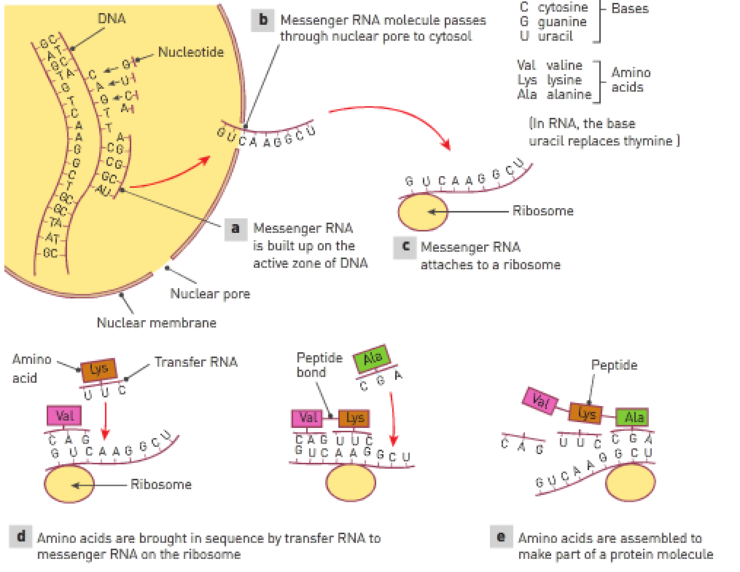

**Mitochondrial DNA**

* A **small amount** of DNA is in the mitochondria. This is called **mitochondrial DNA (mtDNA)**.

2 differences between DNA and mtDNA:

1. Nuclear DNA is in the form of **very long strands** that are **bound to histones**.
2. mtDNA is in the form of **small circular molecules** that **aren’t bound to proteins**.

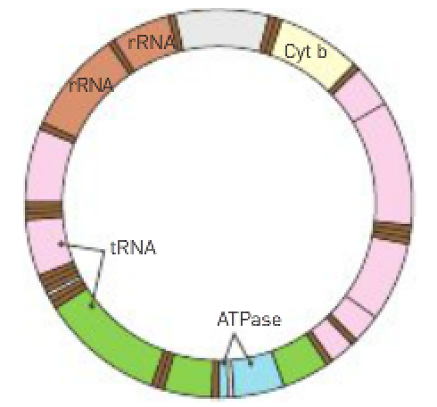

|  |  |
| --- | --- |
| Deoxyribonucleic acid (DNA) | Very large molecule made of 2 strands of nucleotides that are joined by bonds between the nucleotide bases. The 2 strands are twisted in a double helix. Found in the nucleus and mitochondria of cells. |
| Nuclear DNA (nDNA) | DNA found in the nucleus of cells. |
| Mitochondrial DNA (mtDNA) | DNA found in the mitochondria. |
| Ribonucleic acid (RNA) | Large molecule composed of a single strand of nucleotides. |
| Messenger RNA (mRNA) | RNA molecules that carries the code for protein synthesis from the DNA in the nucleus to the ribosomes where the protein is made. |
| Transfer RNA (tRNA) | A small RNA molecule that transfers the correct amino acid to the ribosome for inclusion in the protein molecule being made. |

**WACE Study Guide**:

Protein synthesis:

1. Chromosomes are in their normal condition in the nucleus. Ribosomes are located on the endoplasmic reticulum or free in the cytoplasm.
2. A section of the DNA unzips, exposing a number of nitrogenous bases.
3. Free nucleotides which are in the nucleoplasm move to the exposed nitrogen bases. mRNA forms along the exposed section of DNA (transcription). Uracil replaced thymine in the formation of mRNA.
4. The mRNA moves out of the nucleus, through a nuclear pore to a ribosome. Th e nuclear pores are too small to allow DNA molecules to escape.
5. The mRNA is “read” by the ribosome and acts like a template on the ribosome. tRNA molecules bond to specific amino acids and carry hem over to their matching exposed nitrogenous bases (translation). The anticodons on the tRNA match the codons on the mRNA.
6. A specific amino acid is brought by the tRNA to the beginning of the mRNA molecule. The next amino acid is brought by the next tRNA and positioned next to the previous amino acid.
7. A chemical bond called a peptide bond forms between the amino acids.

|  |  |
| --- | --- |
| Transcription: | Translation: |
| Occurs inside the nucleus.  Is the process that copies the code on part of the DNA onto a strand of mRNA.  The DNA molecule unwinds and one strand of the helix is used a as template.  DNA polymerase joins nucleotides together to form a strand of mRNA.  The sequence of bases on the mRNA is complimentary to that of DNA. | Occurs in the cytoplasm.  Is the process in which amino acids are assembled to form proteins.  mRNA leaves the nucleus and moves to the cytoplasm.  mRNA attaches onto a ribosome.  The anticodon on the tRNA attaches to the codon on the mRNA.  The amino acids from the tRNA are linked together to form the amino acid chain or protein. |

Q: Where is DNA located in the cell?

Most DNA is located in the cell nucleus but small amounts can be found in mitochondria.

Q: What’s a gene and what does it contain?

A gene is a section of DNA. Genes contain the genetic code – the activities that determine the activities and structure of the cell.

Identify all components of a DNA molecule that are important in the structure and activities of the cell.

Each DNA molecule consists of 2 strands of alternating sugars and phosphates with nitrogen base pairs forming between the sugar molecule.

Hydrogen bonding holds the nitrogen bases together.

Adenine can pair only with thymine and cytosine can only pair with guanine in DNA.

A nucleotide is made from just the phosphate group, sugar molecule and nitrogen base attached.

A sequence of 3 bases is the code for a particular amino acid known as a base triplet.

How does RNA and DNA differ?

DNA has 2 strands arranged in a double helix whereas RNA consists of a single strand and therefore is smaller.